We divided the dataset into different blocks. Each block represents a separate country or an area that comes under the radar of data analytics. Our data set contains analytics from 10 different blocks, namely,

Africa, Asia Pacific, CIS, China, Europe, France, Germany, Italy, Mexico, Portugal, United States, World.

Data available regarding these countries is Biofuels Production - TWh - Total, Wind Capacity, Hydro (% sub energy), Electricity from hydro (TWh)_x, Geothermal Capacity, Solar Capacity, Wind Generation - TWh, Solar Generation - TWh, Geo Biomass Other - TWh, Hydro Generation - TWh, Electricity from wind (TWh)_x, Electricity from hydro (TWh)_y, Electricity from solar (TWh)_x, Electricity from other renewables including bioenergy (TWh), Renewables (% sub energy), Hydro (% electricity), Renewables (% electricity), Solar (% electricity), Wind (% electricity), Electricity from solar (TWh)_y, Solar (% sub energy), Electricity from wind (TWh)_y, Wind (% sub energy).

Most of this data is redundant and some of this data is not useful for our machine learning applications. What we need to do is to figure out the trend of individual renewable energies and see if any of them correlate with each other. This way for practical purposes a trend of investment can be figured out for these industries proving beneficial for both the investors and the consumers of these renewable energies.

We first applied 3-degree polynomial regression on each block, taking only four of their features. These features include Electricity from hydro (TWh), Electricity from wind (TWh), Electricity from solar (TWh), Electricity from other renewables including bioenergy (TWh). For the input feature we used year that goes from 2000-2020, and all the other 4 features were the output. This way we performed multi-output polynomial regression on the dataset. This regression analysis allowed us to calculate the prediction for the next year for that block. We give these prediction values in the table below the regression results.

After calculating future prediction, we calculate the correlation that exists between different renewable energies in different regions. What this allows us is that we can see which countries are favoring which renewable energy sector, or if some country is putting extra effort in some sector at the expense of the other.

Here are the results.

# Africa:

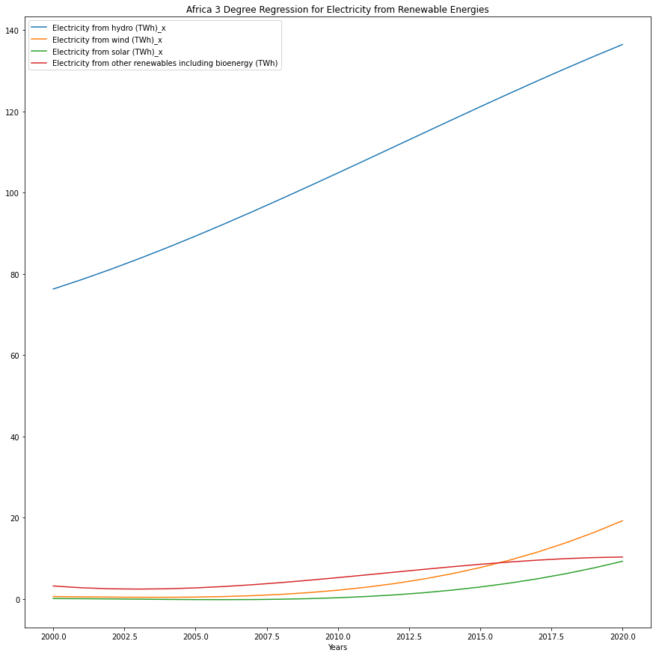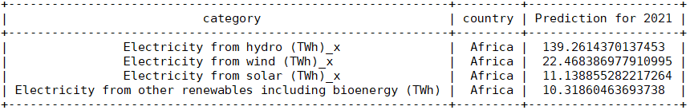

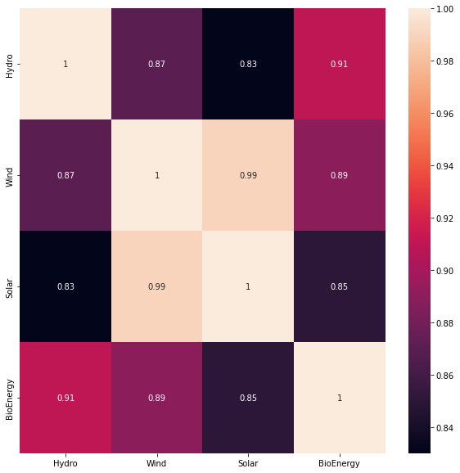

A correlation value of over 0.85 in the heatmap indicates a strong correlation exists between them meaning that if one sector is invested in heavily, the other gets heavy investment too, which in turn generates more energy from that sector.

# Asia Pacific:

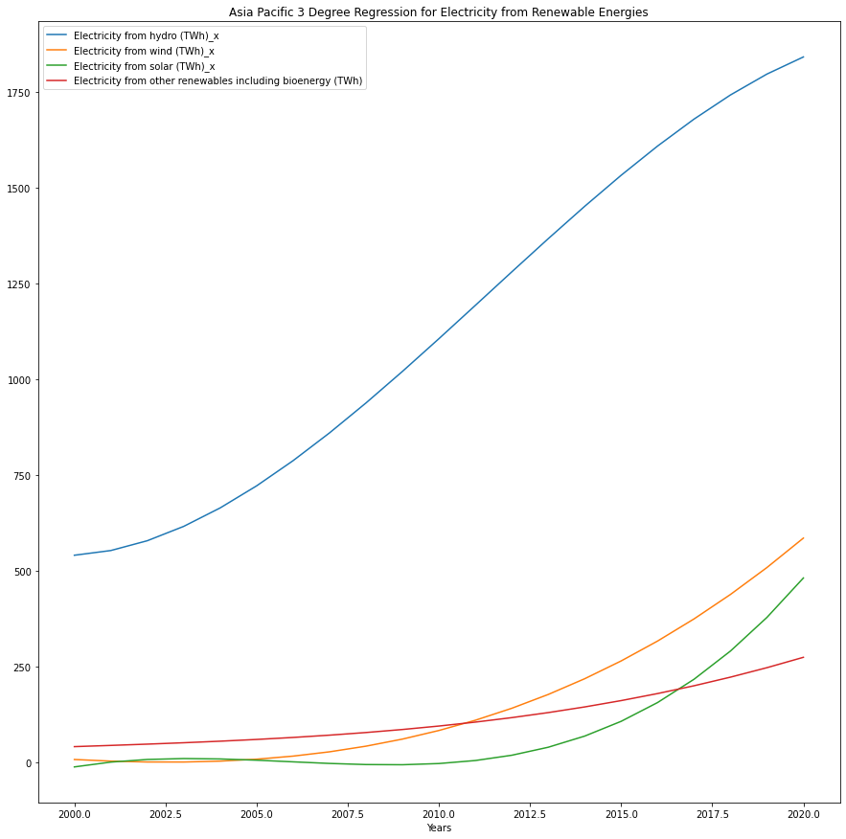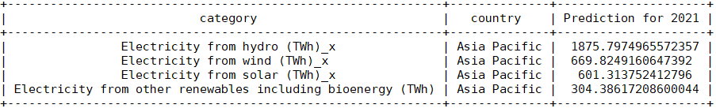

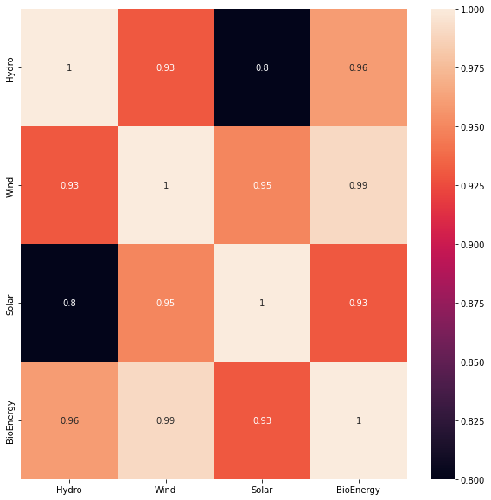

A correlation value of over 0.85 in the heatmap indicates a strong correlation exists between them meaning that if one sector is invested in heavily, the other gets heavy investment too, which in turn generates more energy from that sector.

# CIS:

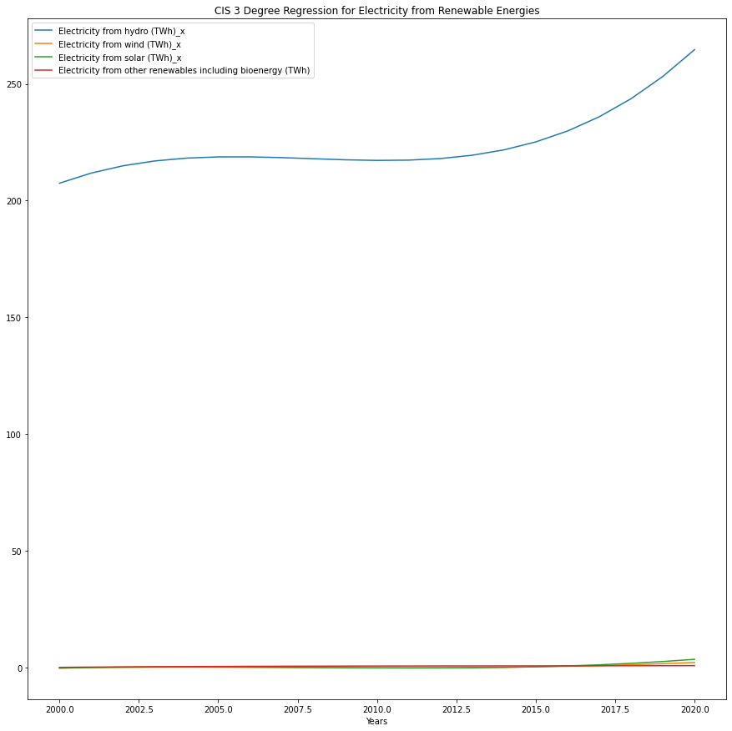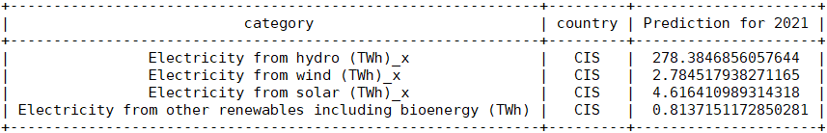

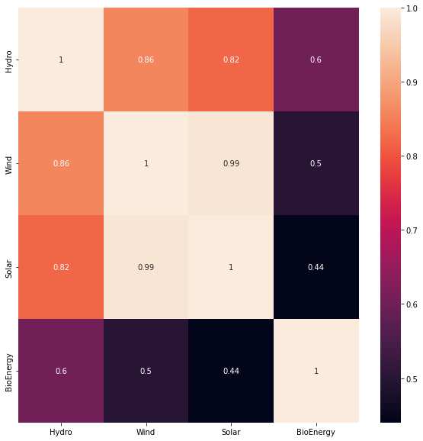

A correlation value of over 0.85 in the heatmap indicates a strong correlation exists between them meaning that if one sector is invested in heavily, the other gets heavy investment too, which in turn generates more energy from that sector.

# China:

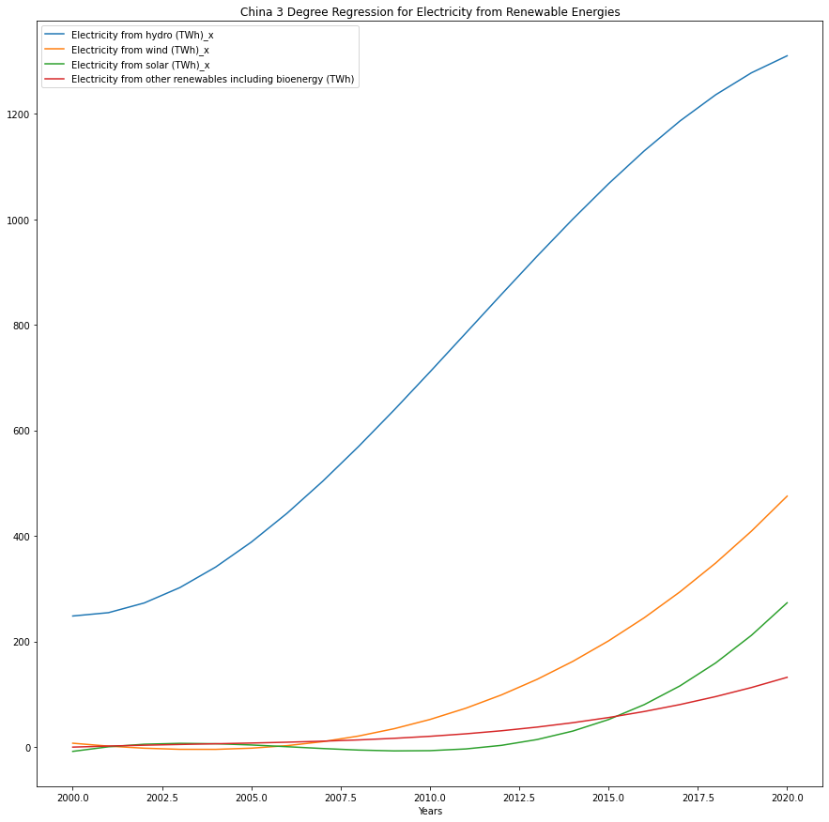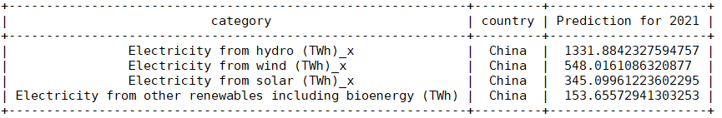

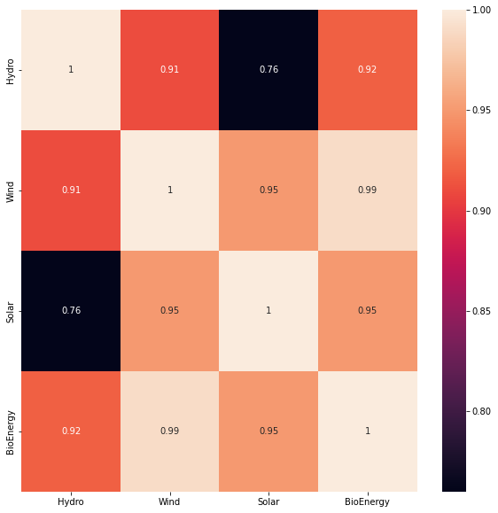

A correlation value of over 0.85 in the heatmap indicates a strong correlation exists between them meaning that if one sector is invested in heavily, the other gets heavy investment too, which in turn generates more energy from that sector.

# Europe:

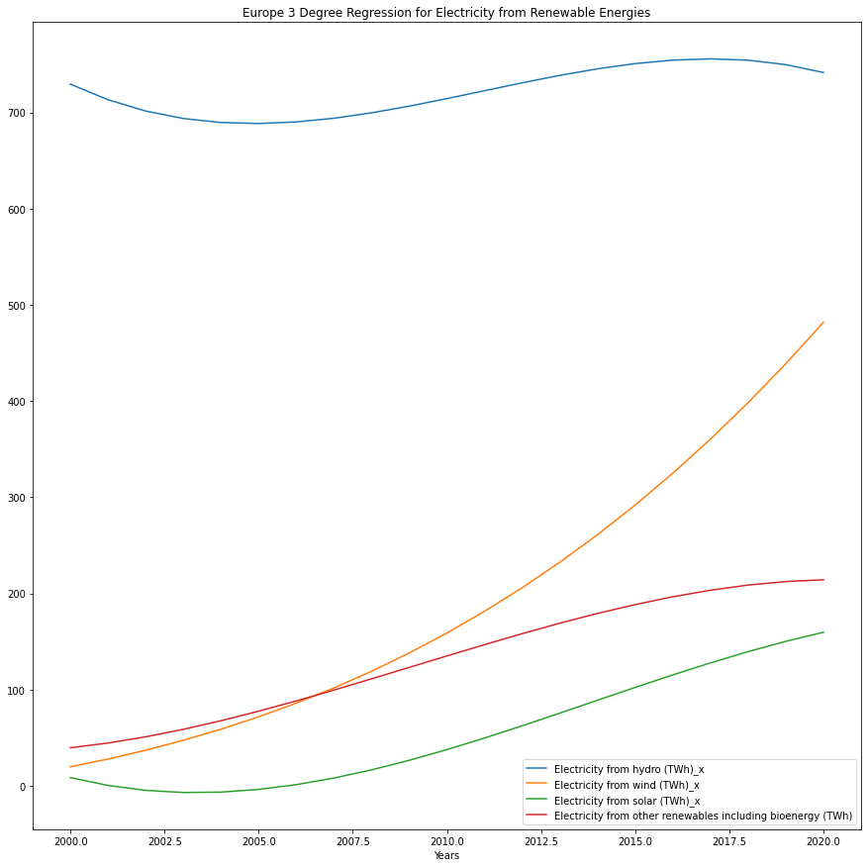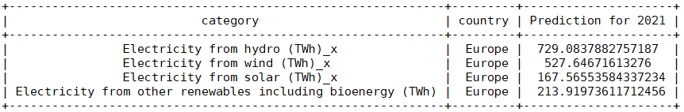

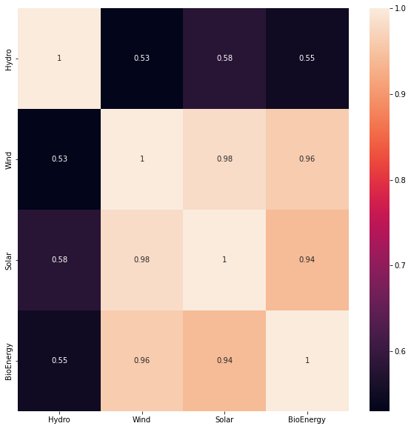

A correlation value of over 0.85 in the heatmap indicates a strong correlation exists between them meaning that if one sector is invested in heavily, the other gets heavy investment too, which in turn generates more energy from that sector.

# France:

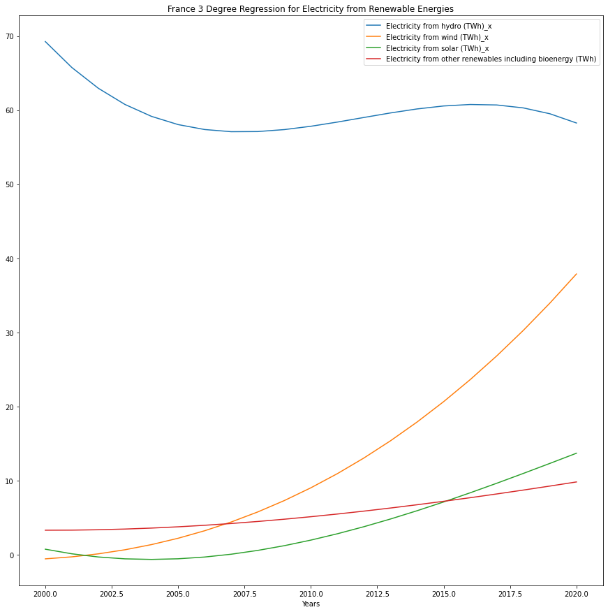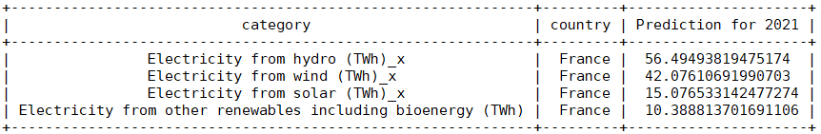

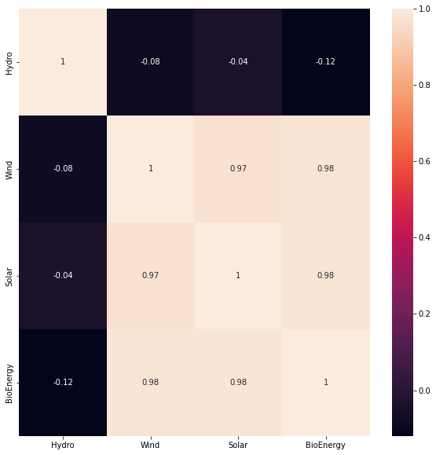

A correlation value of over 0.85 in the heatmap indicates a strong correlation exists between them meaning that if one sector is invested in heavily, the other gets heavy investment too, which in turn generates more energy from that sector.

# Germany:

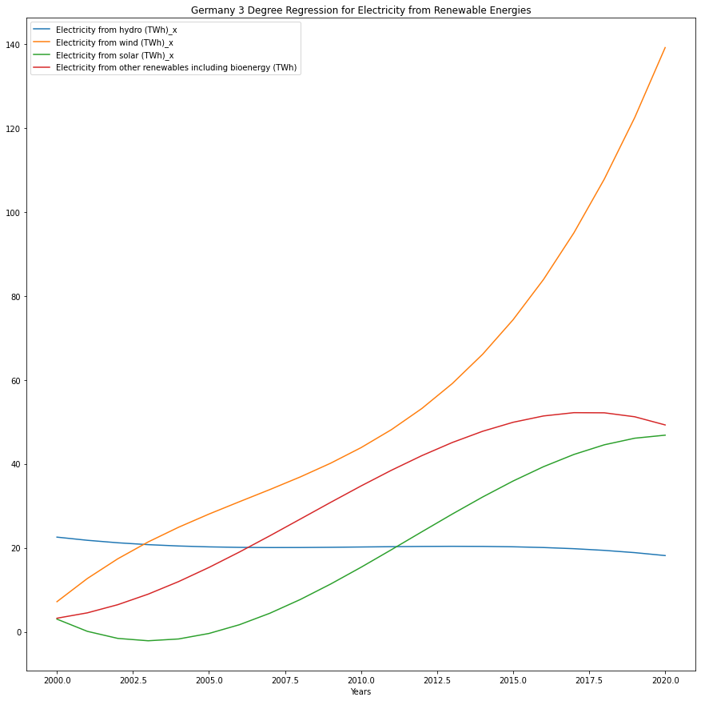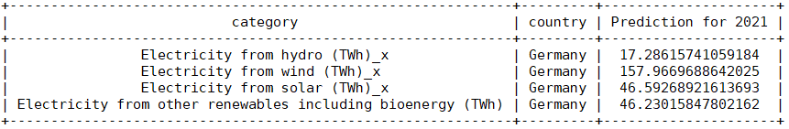

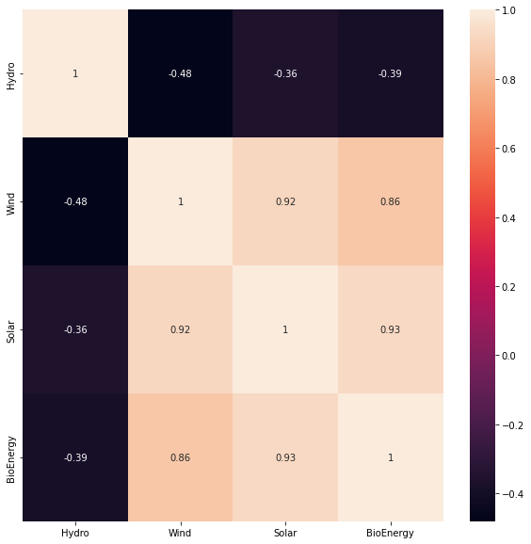

A correlation value of over 0.85 in the heatmap indicates a strong correlation exists between them meaning that if one sector is invested in heavily, the other gets heavy investment too, which in turn generates more energy from that sector.

# Italy:

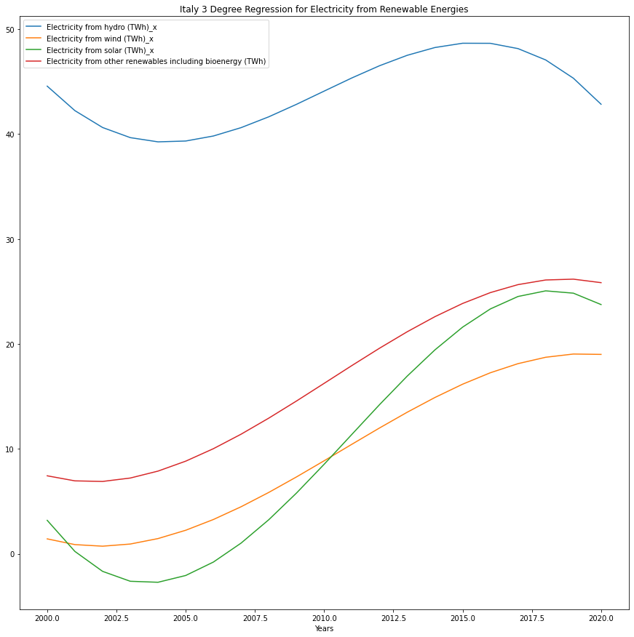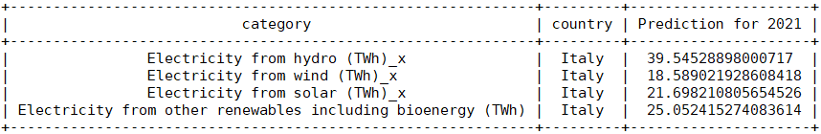

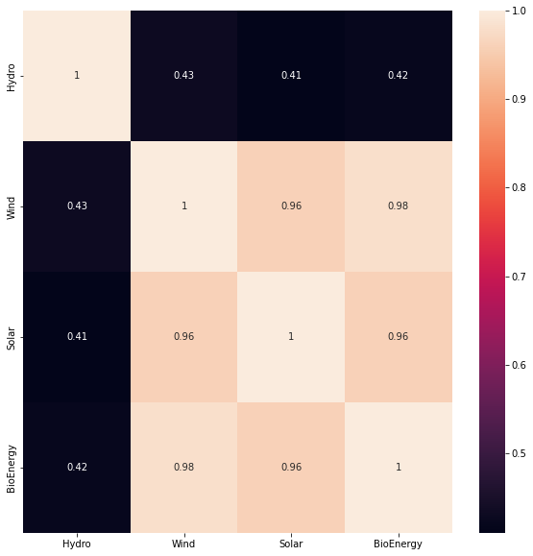

A correlation value of over 0.85 in the heatmap indicates a strong correlation exists between them meaning that if one sector is invested in heavily, the other gets heavy investment too, which in turn generates more energy from that sector.

# Mexico:

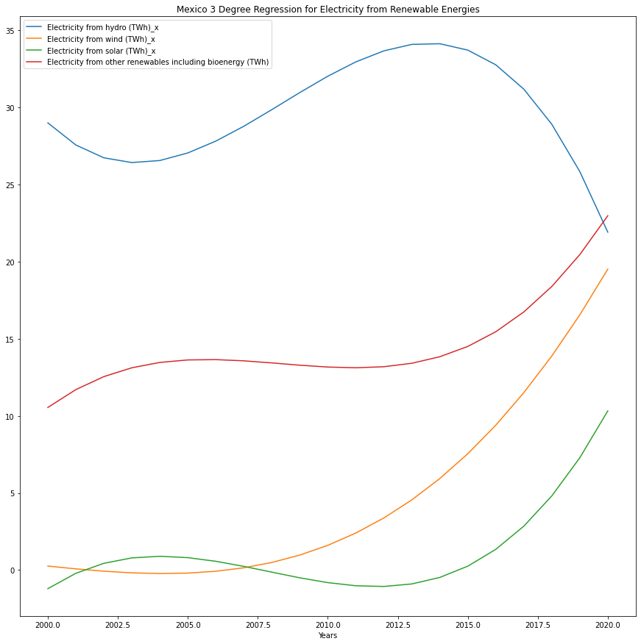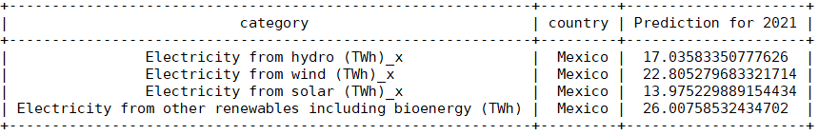

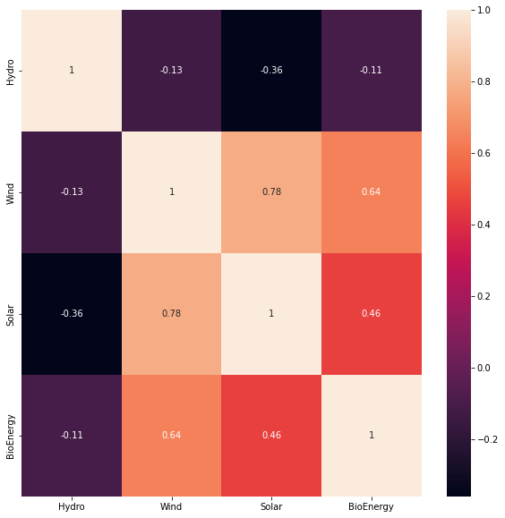

A correlation value of over 0.85 in the heatmap indicates a strong correlation exists between them meaning that if one sector is invested in heavily, the other gets heavy investment too, which in turn generates more energy from that sector.

# Portugal:

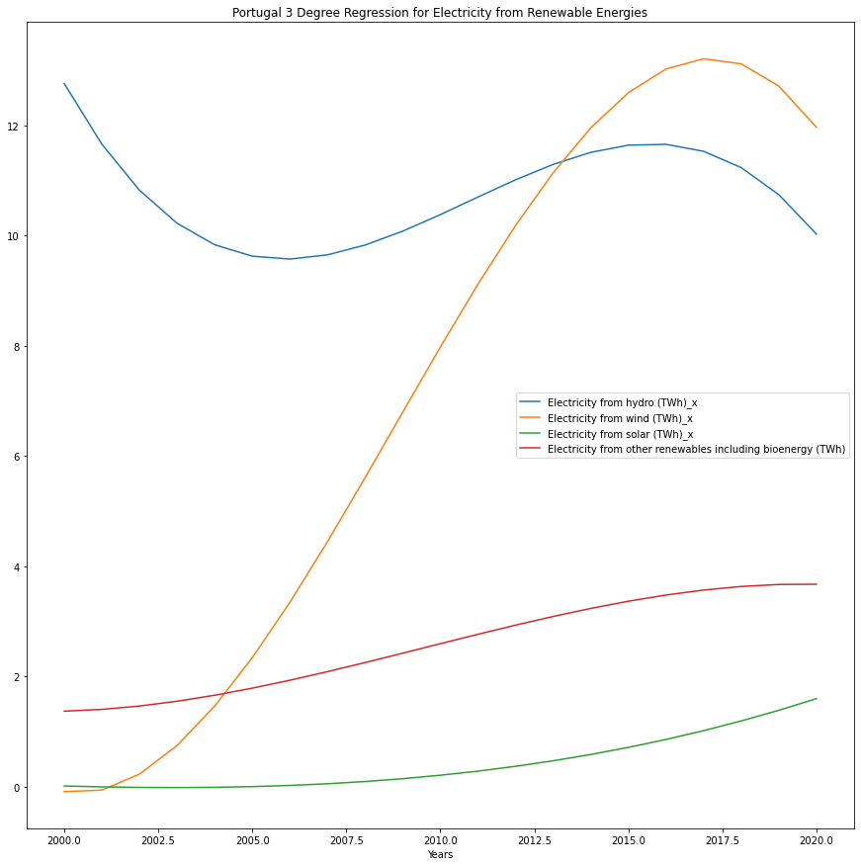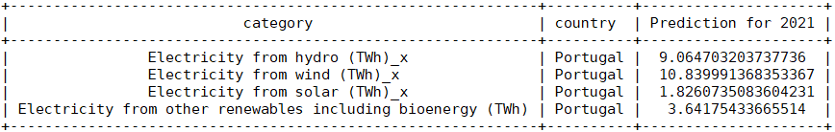

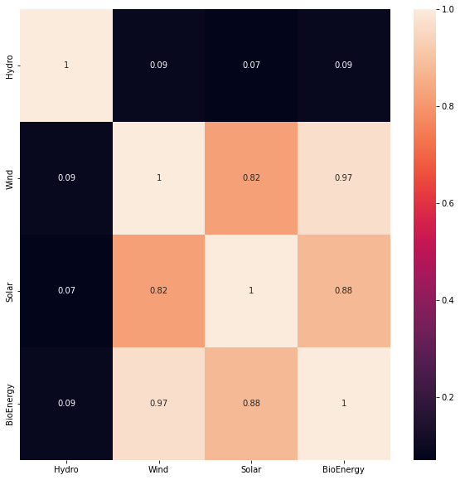

A correlation value of over 0.85 in the heatmap indicates a strong correlation exists between them meaning that if one sector is invested in heavily, the other gets heavy investment too, which in turn generates more energy from that sector.

# United States:

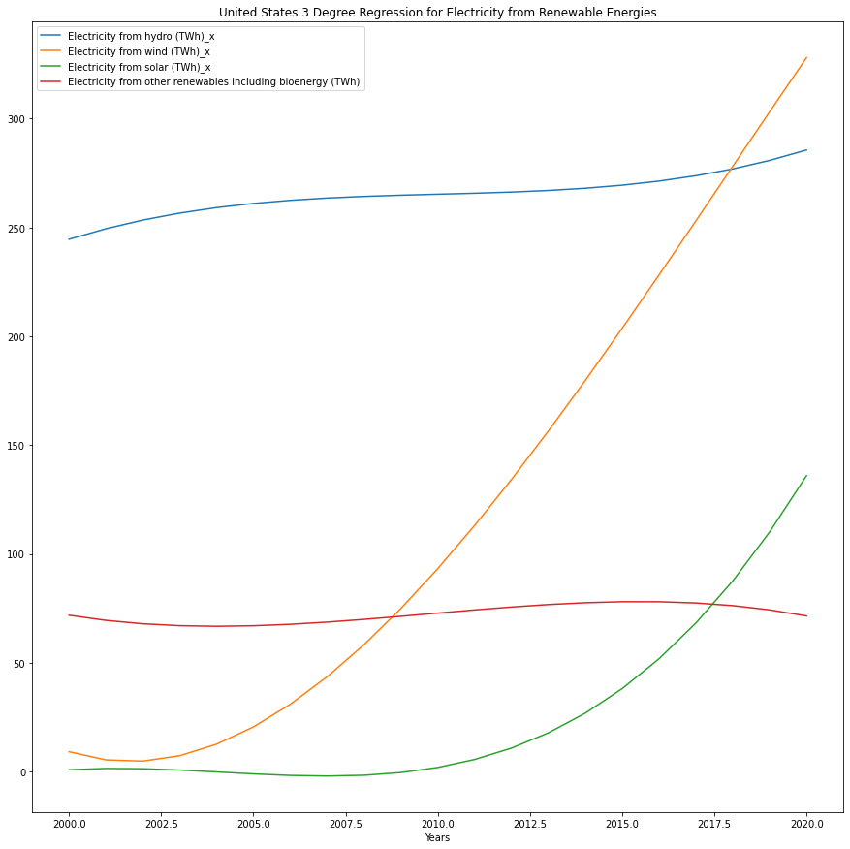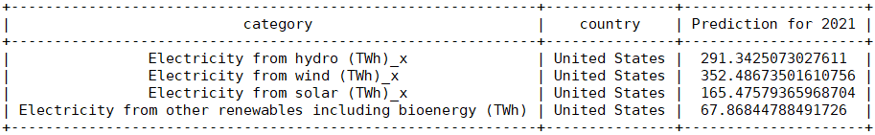

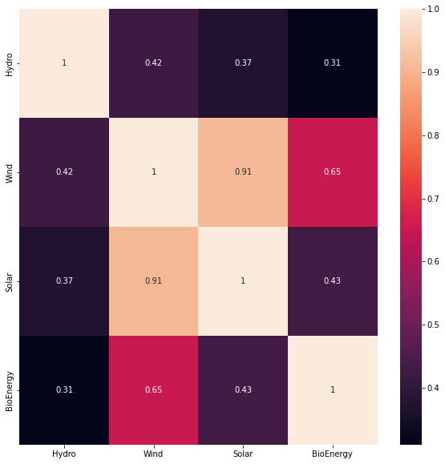

A correlation value of over 0.85 in the heatmap indicates a strong correlation exists between them meaning that if one sector is invested in heavily, the other gets heavy investment too, which in turn generates more energy from that sector.

# World:

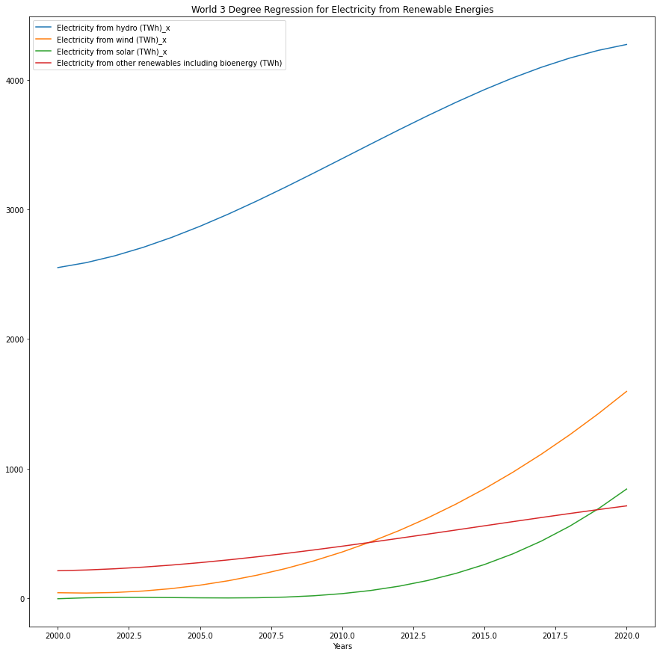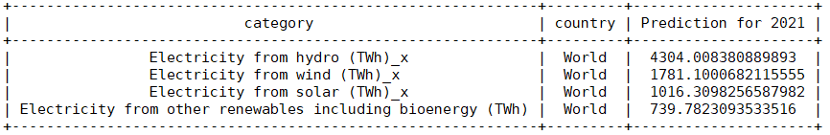

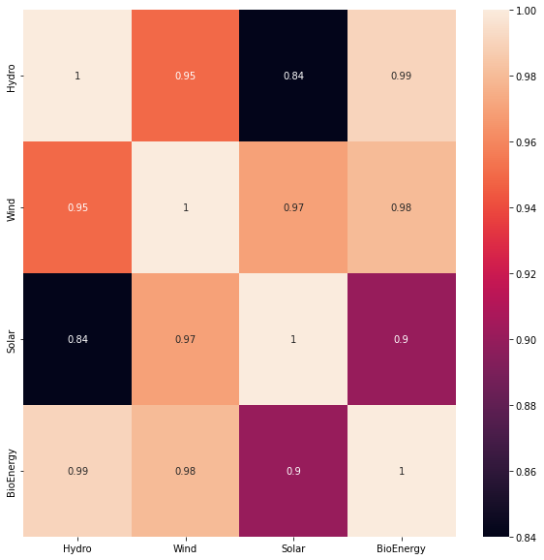

A correlation value of over 0.85 in the heatmap indicates a strong correlation exists between them meaning that if one sector is invested in heavily, the other gets heavy investment too, which in turn generates more energy from that sector.